ANDROID

Android is a software stack for mobile devices that includes an operating system, middleware and key applications. The Android SDK provides the tools and APIs necessary to begin developing applications on the Android platform using the Java programming language.
Operating Systems have developed a lot in last 15 years. Starting from black and white phones to recent smart phones or mini computers, mobile OS has come far away. Especially for smart phones, Mobile OS has greatly evolved from Palm OS in 1996 to Windows pocket PC in 2000 then to Blackberry OS and Android.
One of the most widely used mobile OS these days is ANDROID. Android does a software bunch comprise not only operating system but also middleware and key applications. Android Inc was founded in Palo Alto of California, U.S. by Andy Rubin, Rich miner, Nick sears and Chris White in 2003. Later Android Inc. was acquired by Google in 2005. After original release there have been number of updates in the original version of Android.
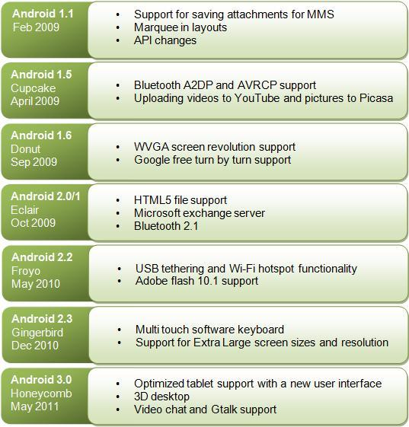
Figure 1: Android Versions and Features

